Startup configuration
After successfully installing all software components, you're now set to initiate the application setup.
The initial configuration phase involves registering tenants and connectors to the installed databases,
allowing for the segregation of configuration and monitoring data into distinct "tenants".

First logon
- Navigate to the application portal: http://[HOST]:[PORT] (Example: http://redpeaks:8888)
- You will be prompted to register the superadmin user.
- This user will have access to the application management portal, allowing to set global settings and to manage tenants
- Once created, you will reach the administration portal
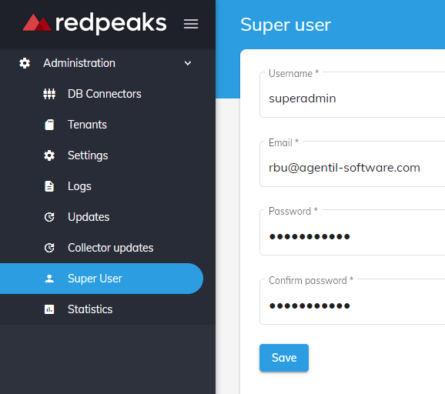

Create DB connectors
At this stage, you have installed MySQL database and created PRIMARY and TENANT databases.
You also completed the instalaltion of victoria metrics

Create MySQL connections
- You are now going to register the connections to the application databases
- Navigate to DB connectors menu
- Press Create and select MYSQL
- Register the connection parameters of your PRIMARY database (activate “primary” checkbox)
- Repeat the operation of all tenant databases

Create Victoria metrics connections
- Press Create and select Victoria metrics
- Register the connection parameters to a victoria metrics database
- Repeat the operation of all metrics databases

Create tenants

