Retention

Alarms
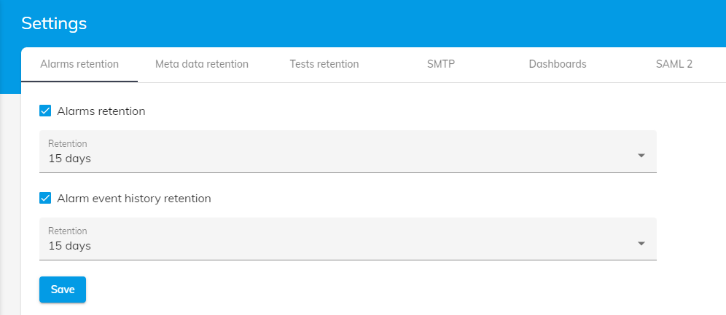
Alarms retention : Defines how long to keep alarms
Alarm event history retention : Defines how long to keep alarms history

Meta data
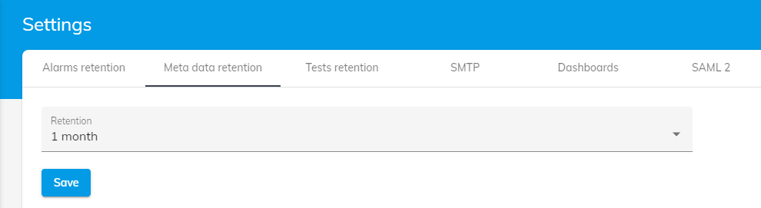
Retention : Defines how long to keep meta data (meta data are used for Dashboard)

Tests
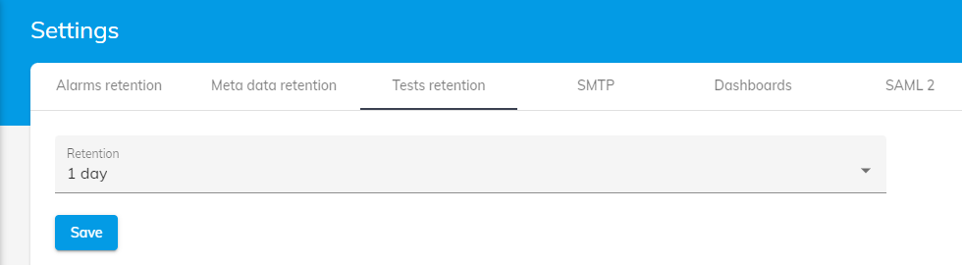
Retention : Defines how long to keep tests monitors executions

