Views
On top of your main page and next to the Configure feature, you will find two tabs : Companies view and Systems view.
Use these tabs to get a complete overview of all Companies or Systems and their particular information such as :
- The number of monitors being affected to Systems
- Monitors that had encountered errors during their execution
- Flapping connectors, etc
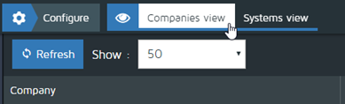

1 - Companies view tab
- When this mode is active, a general information table focused on Companies will be displayed.
- You can refresh data displayed in the table by clicking on Refresh button at any moment
- The number of Companies displayed in one page can be changed selecting a given number of companies on the Show dropdown list
- The table contains the information below described by column header.
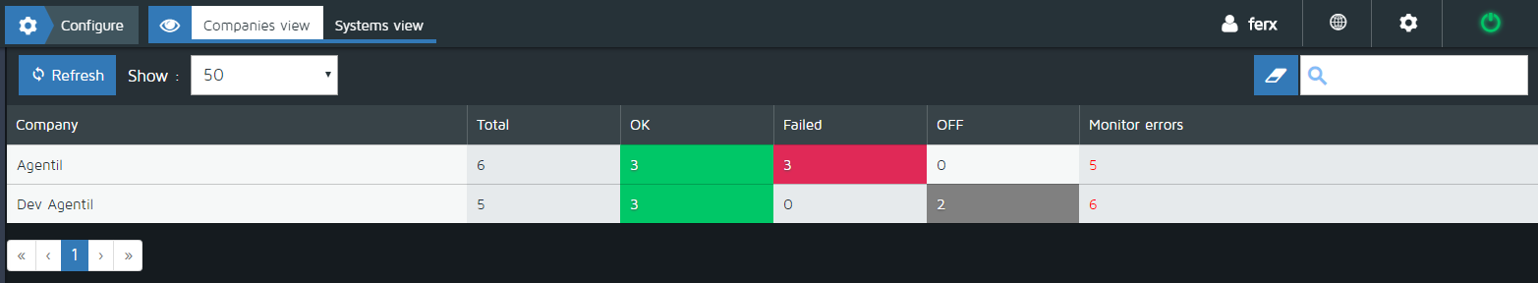

Main table columns :
- Company : The name of each Company
- Total : The total number of connectors (grouping all Company's systems)
- OK : Number of Connectors currently establishing connection to SAP systems
- Failed : Number of Connectors currently failing the connection to SAP systems
- OFF : Connectors currently off (deactivated by Redpeaks users)
- Monitor errors : Number of monitors that ahve ended with an “error” status

2 - Systems view tab
- When this mode is active, a general information table focused on Systems (of all Companies) will be displayed.
- You can refresh the information displayed in the table by clicking on Refresh button at any moment
- Next to “Refresh” button, you will find the following information concerning all systems connectors :
  - Connectors OK : Number of Connectors currently establishing connection to SAP systems
  - FAILED connectors : Number of Connectors currently failing the connection to SAP systems
  - OFF connectors : Connectors currently off (deactivated by Redpeaks users)
  - State unknown connectors : Connectors currently attempting to establish connection to SAP System
  - Monitor errors : Number of monitors that ahve ended with an “error” status
  - Finally, at the right on the screen, you will find the total number of connectors (grouping all Company's systems)
- Use the Action dropdown list to activate or deactivate all selected connectors (see details below)
- The number of Companies displayed in one page can be changed selecting a given number of companies on the Show dropdown list
- Use the Company dropdown list to filter the information displayed on the main table
- Enter a value in the search input field to filter information in the main table on columns : Company, SID, Connector and Type.
- The table contains the information below described by column header:
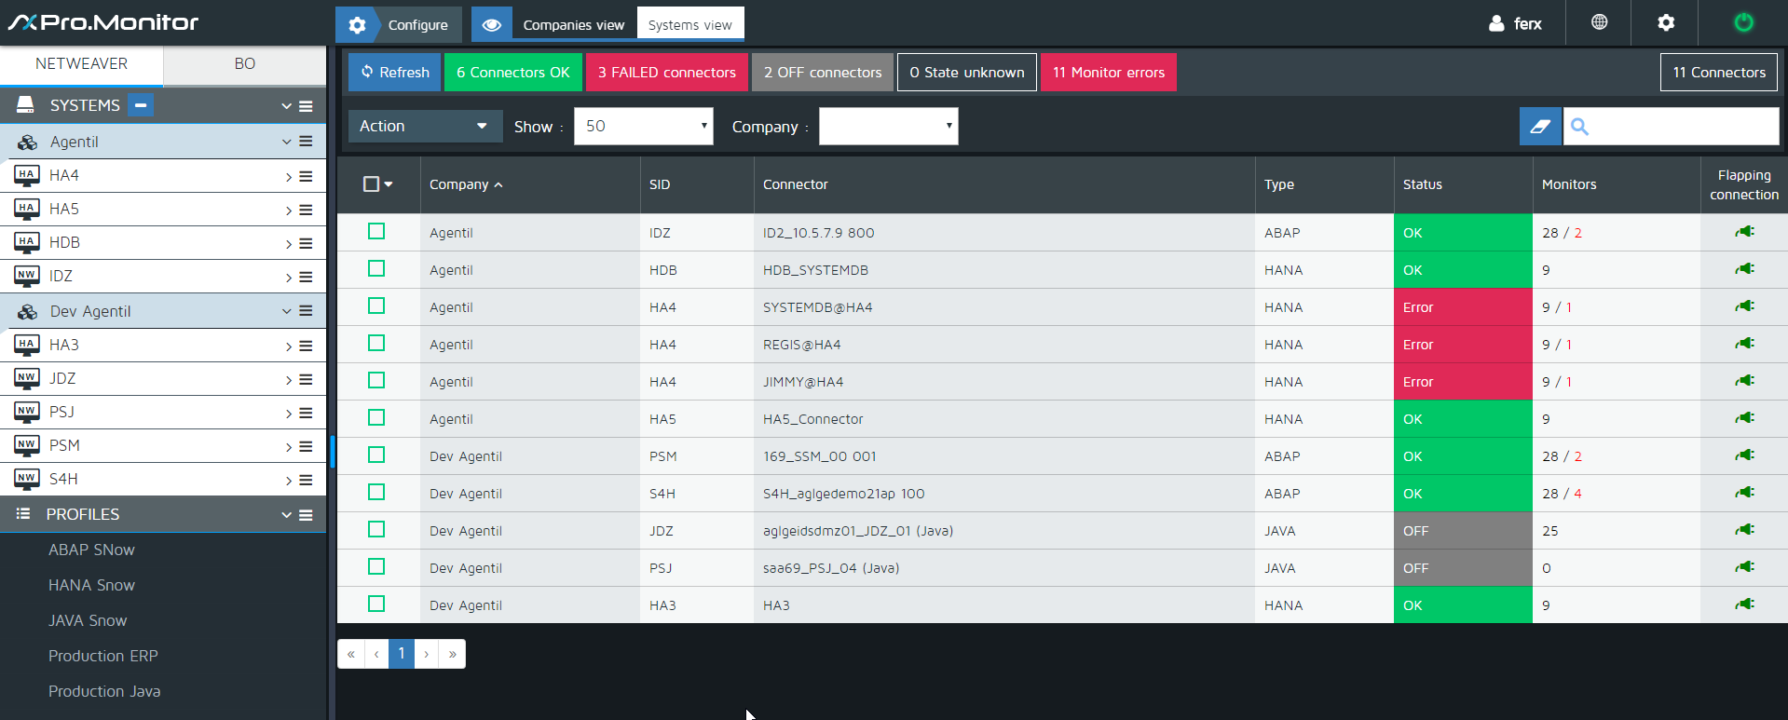

Main table columns :
- Action column : Use this utility column to : check/uncheck all Connectors at once (to activate or deactivate connector using the Action dropdown list)
- Company : The Company name of the system and connector
- SID : The SAP System ID.
- Connector : The connector name
- Type : Connector type (i.e. : ABAP, HANA, JAVA ...)
- Status : The current status of the connector (OK, OFF, FAILED, UNKNOWN)
- Monitors : Number of monitors that have been executed and - in red - those that has been terminated with an “error” status. Click on monitor errors to display errors details
- Flapping connection : Indicated if the connection is currently considered as a “flapping connection”

