Update menu

Purpose
- You can update server and agent application from the web interface.
- This allows to update the application remotely without having access to the OS layer.
- Remote agents attached to the server can be updated too with the uploaded package.
- An OS updater is available if necessary.

Update of Redpeaks collector
- Download the update package provided by Agentil Software (zip file)
- Use the Import new version button to select the update file in your local file system and upload it.
- Once uploaded the package will be listed in the table, showing its version
- Press Install to start installing the update, wait for the confirmation screen acknowledging its success
- To complete installation, you must restart Redpeaks. Go the Maintenance tab on the left and press Restart.
Note: The actual installation happens during restart. If you install an update without restarting, this will not affect the software in place.
Caution: Downgrading Redpeaks is not possible
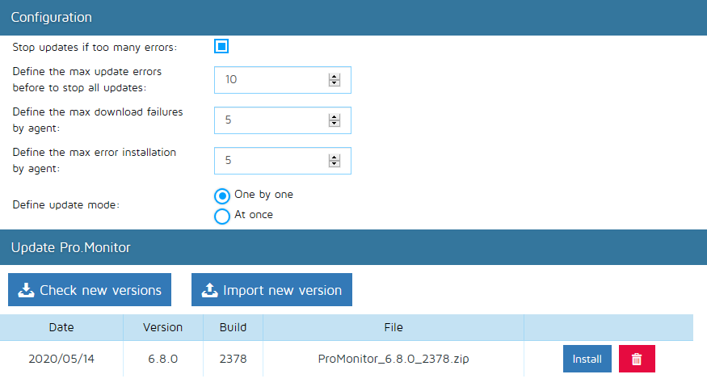

Configuration for remote agents update
In the configuration panel, you can define the update settings for the remote agents:
- Stop update if too many errors: If active, the agent update loop will stop automaticaly
- Max update errors: The max number of errors before stoping the update loop
- Max download failures: The max number of retries an agent can do for downloading a new package
- Max install errors: The max number of retries an agent can do for installing a new package
- Update mode: Define if all agent will update one after the other or all at once

