Elasticsearch Plugin

Purpose
- This plugin allows you to send alarms and metrics directly to an Elasticsearch instance
- Alarms and metrics can be indexed in separate Elasticsearch indices

Configuration
- From the plugin menu of Redpeaks, select Elasticsearch in the plugin drop-down and press Add.
- The plugin has the following parameters:
Parameter | Description | Mandatory
Active | Enables or disables the Elasticsearch plugin | Yes
Configuration | Choose between Standard Configuration or Cloud Configuration | Yes
Hostname | The IP address or hostname of the Elasticsearch instance (Standard Config) | Yes
Port | The port used to connect to Elasticsearch (Default is 9200) | Yes
Cloud ID | The Cloud ID used for connecting to a cloud-based Elasticsearch instance (Cloud Config) | Yes
API Key | The API key for authentication (Cloud Config) | Yes
Name | A unique name for the plugin instance | Yes
Alarm Index | The Elasticsearch index where alarms will be stored | Yes (if Send alarms checked)
Metric Index | The Elasticsearch index where metrics will be stored | Yes (if Send metrics checked)
Username | The username for Elasticsearch authentication | No
Password | The password for Elasticsearch authentication | No
Properties | A semicolon-separated list of additional Elasticsearch properties | No
Max queue size | The maximum size of the queue holding alarms and metrics | Yes
Send alarms | If active, alarms received by the plugin will be sent to Elasticsearch | No
Send metrics | If active, metrics received by the plugin will be sent to Elasticsearch | No

Indices
You can specify different indices for alarms and metrics in Elasticsearch. The data will be indexed according to the configured settings, allowing for efficient search and retrieval.

Properties
- Properties are key/value pairs separated by semicolon: setting1=value1;setting2=value2
- Common Elasticsearch properties include settings for index refresh intervals, number of replicas, etc.

Example

Standard Configuration
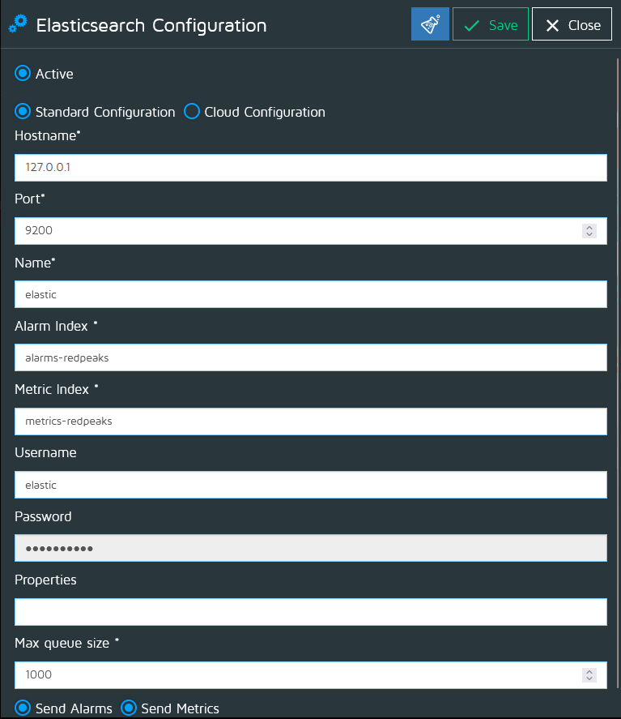

Cloud Configuration
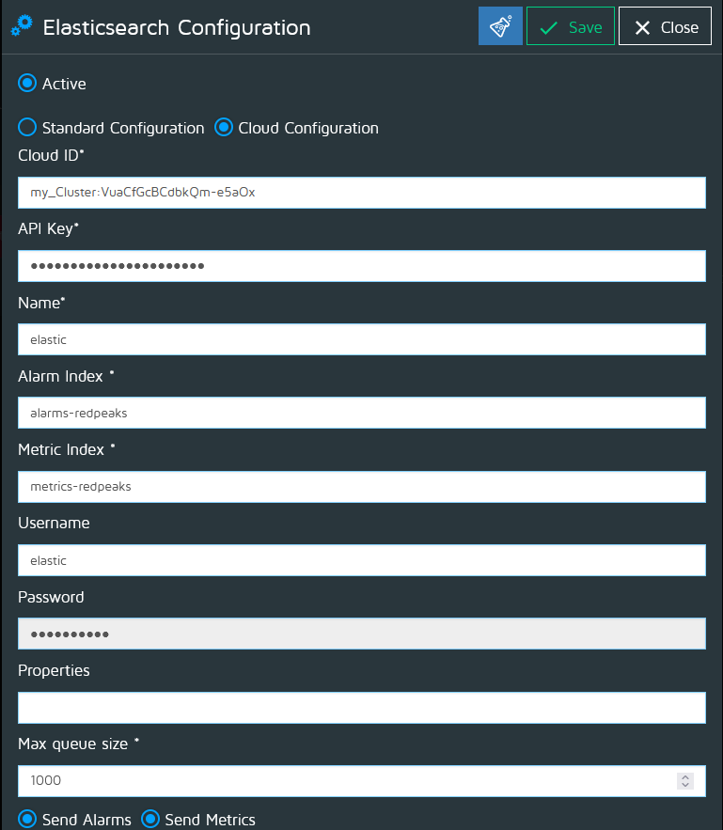
Note: Ensure that the Elasticsearch instance is reachable and properly configured to accept data from your application.

Troubleshooting
If you encounter issues:
- Verify the hostname and port (Standard Configuration) or the Cloud ID and API key (Cloud Configuration).
- Check Elasticsearch logs for any errors related to authentication or index operations.
- Ensure that the indices specified in the configuration exist in Elasticsearch and have the appropriate permissions set for the configured user.

