Redpeaks Cockpit Plugin

Purpose
- This plugin integrates with the Redpeaks Cockpit, allowing for the centralized management and monitoring of your applications and infrastructure

Configuration
- From the plugin menu of Redpeaks, select Redpeaks Cockpit in the plugin drop-down and press Add
- The plugin has the following parameters:
Parameter | Description | Mandatory
Enabled | Enables or disables the Redpeaks Cockpit plugin | Yes
Name | A unique name for the plugin instance | Yes
URI | The URI of the Redpeaks Cockpit instance | Yes
Chunk | The size of data chunks to be sent to Redpeaks Cockpit | Yes
API Key | The API key used for authentication with Redpeaks Cockpit | Yes

Example
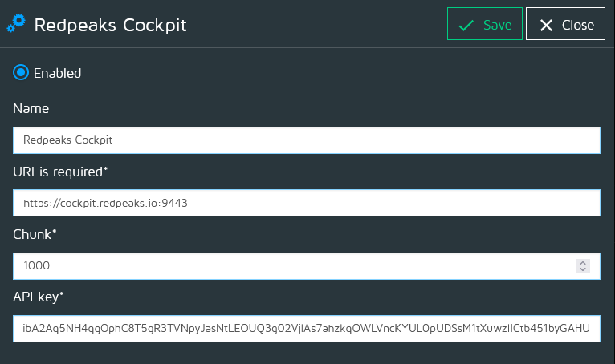
Note: Ensure that the Redpeaks Cockpit instance is reachable and properly configured. The API key must be valid for the data to be accepted

Note
- If you connect on the cockpit via HTTPS and if the certificate used by the cockpit is self signed, you must import the certificate in the collector .keystore
- Use Settings->Admin configuration->HTTPS menu

Troubleshooting
If you encounter issues:
- Verify that the URI is correct and accessible from your network
- Ensure the API key is valid and has the necessary permissions in Redpeaks Cockpit
- Check in Redpeaks Cockpit to ensure it is correctly associated with the plugin
- Be sure that the chunk size is sufficient for the amount of data generated by monitored system to avoid any data loss or performance issues

