Web service connector
The web service connector can be used to monitor HTTP API endpoints, such as any REST service or SAP CPI/BTP cloud instances

Configuration
Parameter | Description
Title | The display name of the connector
URL | The base URL of the web service
Authentication type | The authentication method to use
User | The user credentials to use for BASIC authentification
Availability end point | If set, this will be used to test Web service availability
Authentication server | OAUTH2 authentication server providing tokens
Client Id | The client Id for OAUTH client authentication
Client secret | the client secret for OAUTH client authentication
Client authentication mode | To use with OAUTH, defines how authentication parameters are sent
Access Token | The token to use for Bearer token authentication
Authentication parameters | Used to specify additional header parameters and for future use
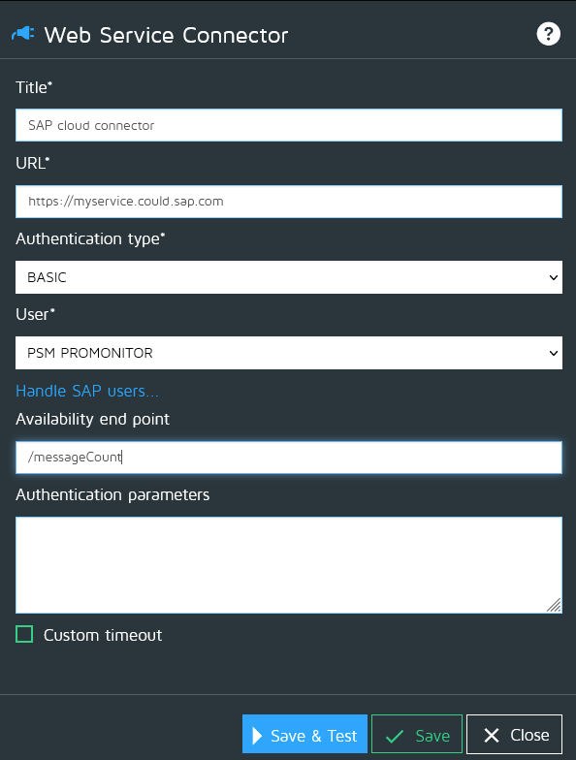

Authentication method
Method | Description
NONE | Connect without authentication
BASIC | Do a basic authentication using the provided user profile
TOKEN | Do an authentication with a Bearer Token, you must set the tocken field
HEADERS | Authentication by headers: Set the header key=value to use in the properties
OAUTH2_CLIENT_CREDENTIALS | Use OAUTH2 and authenticate to token server with a clientId/secret pair
OAUTH2_PASSWORD_CREDENTIALS | Use OAUTH2 and authenticate to token server with the user/password pair of the assigned user profile

Availability metric
- The metric used to set connector availability is “webservice_availability”.
- It will be set to 1 if the connector successfully connects to the availability end point. It will be set to 0 otherwise.

Custom timeout
- See Custom timeouts

