Memory tuning

Redpeaks memory allocation
Please find below the necessary steps to set the Redpeaks (Java program) memory allocation depending on your operating system

For Windows
- Stop ProMonitor Windows service
- To set Redpeaks Java heap :
- Go to [Redpeaks installation folder]\Promonitor\bin
- Run pro_monitorw.exe
- Open the Java tab
- It is recommanded to :
  - Set (as shown in the image below) the starting JVM memory allocation at least to 512 MB (initial memory pool)
  - Set the maximum heap size (maximum memory pool) at least to 2048 MB.
- These setting are ment to control the amount of memory Redpeaks (Java program) will use
- Restart ProMonitor Windows service
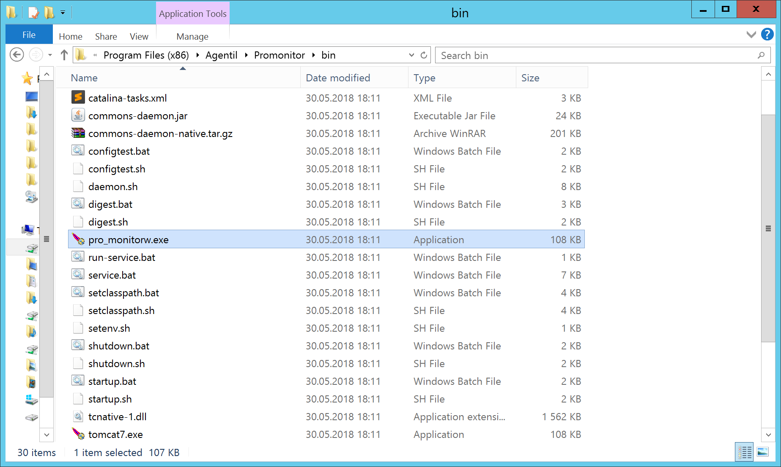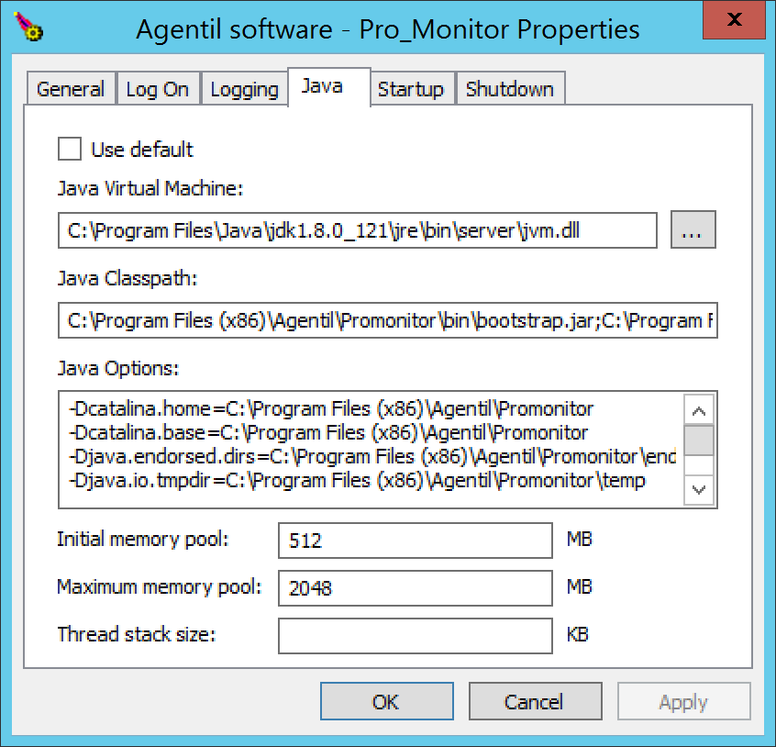

For Linux
- Stop ProMonitor using the command : systemctl stop promonitor
- Go to folder : [path_to_ProMonitor_installation_folder]/bin
- Edit the file setenv.sh
- Set the values of -Xms and -Xms to the desired values (-Xmx to - at least - 4096 MB)
- Restart ProMonitor using the command : systemctl start promonitor
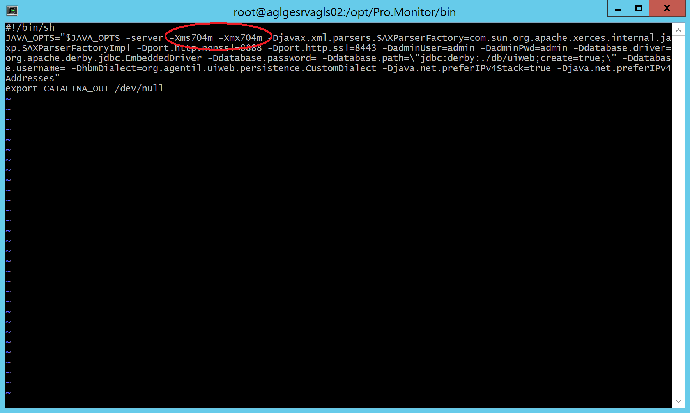

8.2 - Redpeaks monitoring batches memory allocation
- There is also the possibility to fully configure memory allocation to monitoring processes (scheduled batches)
- To access this feature : Administrator Settings -> Admin Configuration -> system -> Worker settings section
- For detailed information visit : worker settings

