Memory usage
The Redpeaks service will be spread over two processes:
- The configuration server: Web server and configuration engine
- The monitor worker: Connects to the systems and perform monitoring analysis

Server
The memory used by the server is set to 2 GB by default
It can be modified by running pro_monitorw.exe located in the bin folder of Redpeaks install path.
You can modify the maximum memory used by the server in the maximum memory pool field
You need to restart the service after changing this settings
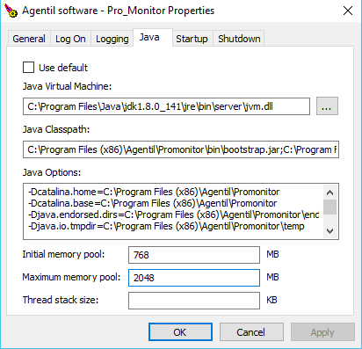

Monitor Worker
The monitor worker is configured by default to use a maximum of 2 GB
The amount of memory used by the worker depends on the following:
- The number of parallel tasks allocated to the worker
- The number of monitored SAP systems
- The configuration of the monitoring (The more monitors are active, the more memory will be consumed)
To modify the memory used by the worker, open the admin config menu and select system tab :
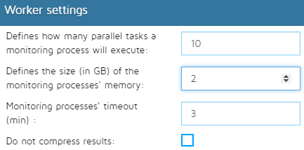

Recommended settings
SAP systems | Worker Memory | Parallel tasks
<50 | 2 GB | 10
<100 | 4 GB | 30
>100 | 6 GB | 50

