Unified Infrastructure Manager Plugin

Purpose
- The Unified Infrastructure Manager plugin gives the possibility to the CA UIM’s “promonitor” probe to collect metrics, alarms and metadata
- Once active, this plugin will collect all generated alerts, metrics and metadata and store them waiting for the probe to collect them
- To limit memory usage the number of element temporally stored is limited
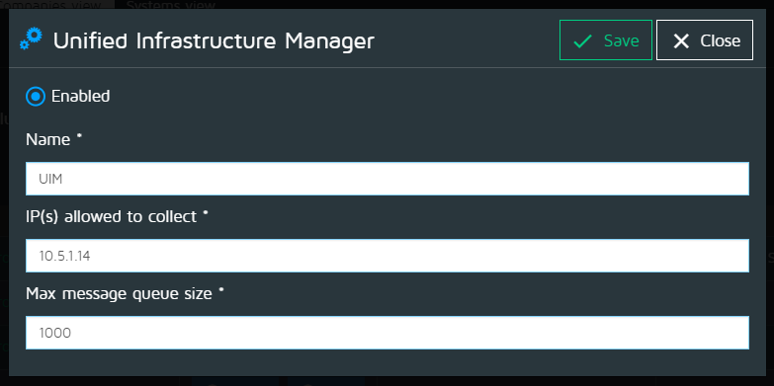

Configuration
- Configure Redpeaks to activate CA UIM plugin:
  - This will make alerts and metrics available for collection by UIM
- CA UIM: Install and deploy promonitor probe.
  - It will connect to Redpeaks to collect available metrics and alarms
  - It will inject alarms and metrics in UIM's DB via the message bus.

Redpeaks
- From the plugin menu, select type Unified Infrastructure Manager and create the plugin, this will open plugin configuration screen
- Fill the plugin settings form:
  - Enabled: To enable or disable the plugin
  - Name: The name of the plugin to display in the list of plugins
  - IP(s) allowed to collect: The IP(s) of the robot(s) with a promonitor probe installed that are allowed to collect data from Redpeaks
  - Max message queue size: The maximum number of alerts or metrics waiting in the output buffer. Used to limit the memory usage if events are created faster than consumed.
Note: If the promonitor probe is deployed on the same robot than sapbasis_agentil probe, the former configuration file will be automatically uploaded in Redpeaks and available in the Snapshots menu

Import configuration from sapbasis_agentil to Redpeaks
- From the snapshot menu, upload sapbasis_agentil.json file like any regular snapshot file.
- Apply the uploaded configuration. This will replace any existing configuration
Note: This operation will not replace the current licences of Redpeaks

Deploy UIM dedicated Probe
- Prerequisites:
  - UIM promonitor probe is a Java application, you must deploy a jre probe before on the same robot
- Download the promonitor probe here: https://agentil.box.com/s/pdoe91amgq5gegdd9u9okx29l743s9do
- Open the Web admin console or the Infrastructure Manager
- Go in the Archive view/tree
- Open the host holding the probe archives and select import in Action/Contextual menu
- Select the probe archive and apply
- It will appear in the list of probes
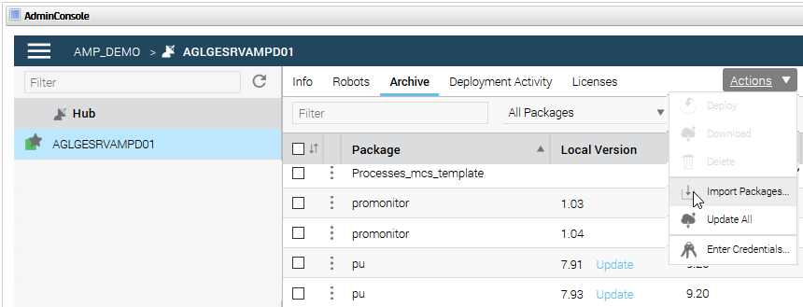
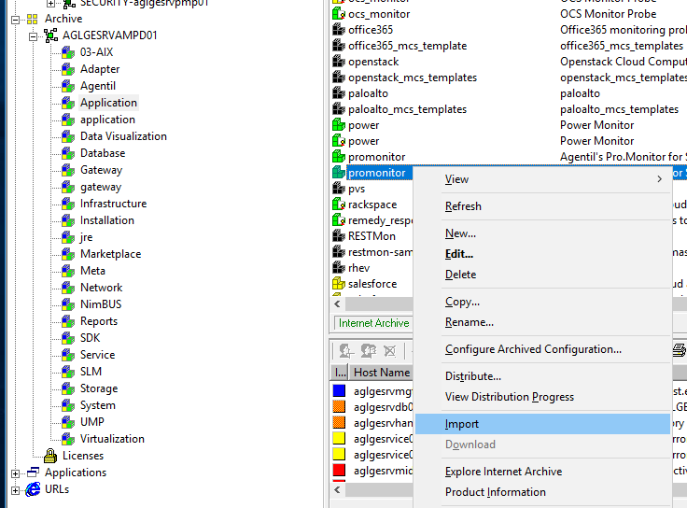
- To install the probe on the selected robot:
  - Web Console: select the probe in the archive and select deploy in the contextual menu
  - Infra. Manager: Drag&Drop the probe on the selected robot
- The probe will be deployed on the robot and ready for configuration
- Right click on the probe in the robot and press Raw configure or Configure...
- Set the fields accordingly:
  - port: Redpeaks port number (HTTP or HTTPS)
  - hostname: Redpeaks's host
  - secureConnection: Set to true to use HTTPS
  - logLevel: 1 - Low, 2 - Medium, 3 - High
- Then activate the probe
- Open the probe's logs via contextual menu to check connectivity and data collection.


