Elasticsearch Plugin

Purpose
- This plugin allows you to send alarms, metric and monitor metadata directly to an Elasticsearch instance
- Alarms, metrics and monitor metadata can be indexed in separate Elasticsearch indices
- Built-in retry mechanism on Elasticsearch overload (HTTP 429 / rejected execution)
- Supports bulk indexing, buffering to protect Elasticsearch under load

Configuration
- From the plugin menu of Redpeaks, select Elasticsearch in the plugin drop-down and press Add.
- The plugin has the following parameters:
Parameter | Description | Mandatory
Active | Enables or disables the Elasticsearch plugin | Yes
Configuration | Choose between Standard Configuration or Cloud Configuration | Yes
Hostname | The IP address or hostname of the Elasticsearch instance (Standard Config) | Yes
Port | The port used to connect to Elasticsearch (Default is 9200) | Yes
Cloud ID | The Cloud ID used for connecting to a cloud-based Elasticsearch instance (Cloud Config) | Yes
API Key | The API key for authentication (Cloud Config) | Yes
Name | A unique name for the plugin instance | Yes
Alarm Index | The Elasticsearch index where alarms will be stored | Yes (if Send alarms checked)
Metric Index | The Elasticsearch index where metrics will be stored | Yes (if Send metrics checked)
Metadata Index | The Elasticsearch index where metadata will be stored | Yes (if Send metadata checked)
Username | The username for Elasticsearch authentication | No
Password | The password for Elasticsearch authentication | No
Properties | A semicolon-separated list of additional Elasticsearch properties | No
Max queue size | The maximum size of the queue holding alarms and metrics | Yes
Send alarms | If active, alarms received by the plugin will be sent to Elasticsearch | No
Send metrics | If active, metrics received by the plugin will be sent to Elasticsearch | No
Send Metadata | If active, metadata received by the plugin will be sent to Elasticsearch | No
Split Metadata | Sends metadata as multiple documents (one per array element) | No
Use Datastream | Uses datastream templates and datastream indexing (recommended for time-series) | No
Create Templates | Automatically creates index templates (required for datastream mode) | No
Use Compression | Enables HTTP compression on Elasticsearch requests | No

Indices
You can configure different indices (or prefixes) for alarms, metrics, and metadata.
- When Create Templates is enabled, the plugin automatically creates index templates
- When Use Datastream is enabled, data is indexed into Elasticsearch datastreams
If templates are disabled and datastream too, the plugin can attempt a fallback index creation if an index does not exist

Properties
- Properties are key/value pairs separated by semicolon: setting1=value1;setting2=value2
- Common Elasticsearch properties include settings for index refresh intervals, number of replicas, etc.

Example

Standard Configuration
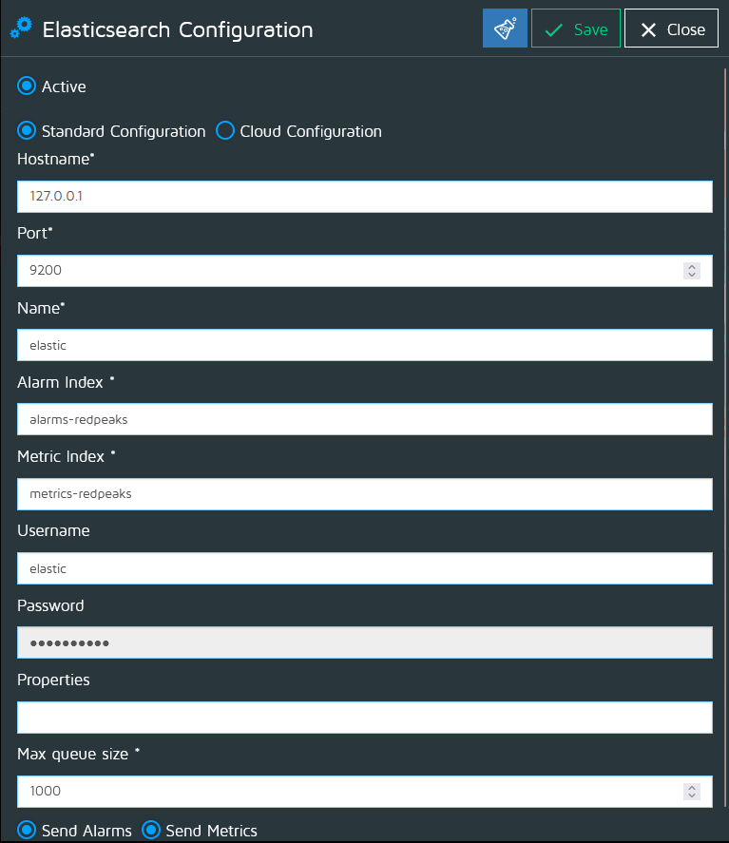

Cloud Configuration
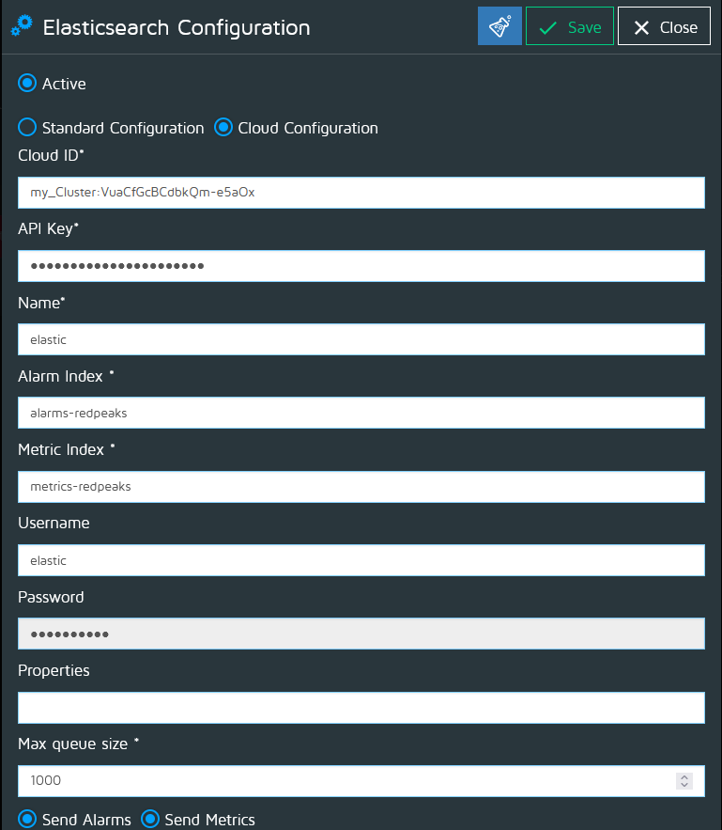
Note: Ensure that the Elasticsearch instance is reachable and properly configured to accept data from Redpeaks The configured user or API key must have permission to write documents and manage templates if enabled

Troubleshooting
If you encounter issues:
- Verify the hostname and port (Standard Configuration) or the Cloud ID and API key (Cloud Configuration)
- Check Elasticsearch logs for any errors related to authentication or index operations
- Ensure that the indices specified in the configuration exist in Elasticsearch and have the appropriate permissions set for the configured user
- If Elasticsearch is overloaded (HTTP 429), consider reducing the batch size or increasing cluster capacity

