Systems and connectors
- Several types of systems can be monitored by Redpeaks.
- For each type of system will correspond types of connectors
- For NetWeaver, S/4HANA and HANA systems, connectors can be created automatically via the SLD, but also manually.
- Following section will describe available connectors for each type of system

Communication
- The connectors will define which protocol is going to be used to connect to the systems
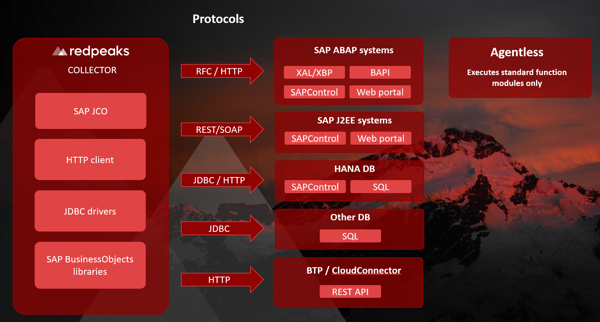

SAP NetWeaver and S/4HANA
- ABAP connector: Connects to the ABAP stack via the message server, using RFC protocol, with a communication user.
- SAPControl connector: Connects to the SAP management console via a SOAP web service, with an OS user.
- Web client connector: Connects to the web portal

SAP HANA database
- HANA SQL connector: Connects to the database with an SQL connection, using an DB user.

SAP BusinessObjects
- CMS/CMC portal connector: Connect to the CMS and CMC portal with a dedicated user

SAP ASE database (SYBASE)
- SAP ASE connector: Connects to the database with a JDBC connection, using a DB user.

Oracle database
- Oracle connector: Connects to the database with a JDBC connection, using a DB user.

MSSQL database
- MSSQL connector: Connects to the database with a JDBC connection, using a DB user.

MaxDB database
- MaxDB connector: Connects to the database with a JDBC connection, using a DB user.

DB2 database (in progress)
- DB2 connector: Connects to the database with a JDBC connection, using a DB user.

SAP Cloud connector
- Cloud Connector Uses the generic Web service connector

Generic Web service connector
- Web service connector: Connects to any web service, must be used for SCPI

BTP connector
- BTP connector: Connectos to BTP

Common settings
- Common settings: Common parameters to all connectors

