Oracle connector

Purpose
- With the Oracle connector, you can connect to an Oracle database via a JDBC driver.
- The database will then be monitored by querying information from the database with SQL requests
- To create connector, there are two steps:
  - Create a user profile in the database and register it in Redpeaks
  - Create and set connector parameters

Create user profile
- User profiles can be created via the Configure menu
- Once created, the user profile can be selected in the connector form
- Note: A user profile is by default associated with a company . You can explicitly set a profile to be cross companies. The effect is that it will be selectable from connectors of any companies.
- The corresponding user must be created in the database as well.

Create connector
- Select the system in the Systems tree and select “Add connector” in its contextual menu, choose Oracle type.
- Fill in the connector parameters:
  - Title The display name of the connector
  - Host: The hostname or IP address of the database host
  - Port: The port of the database service (Default is often 1521)
  - Database name: The database to connect to
  - User: The user profile to use for the connection
  - Properties: Optional properties to add to the connection parameters (separated with semicolon (;)
Press Save & Test to save the profile and check the connection is working
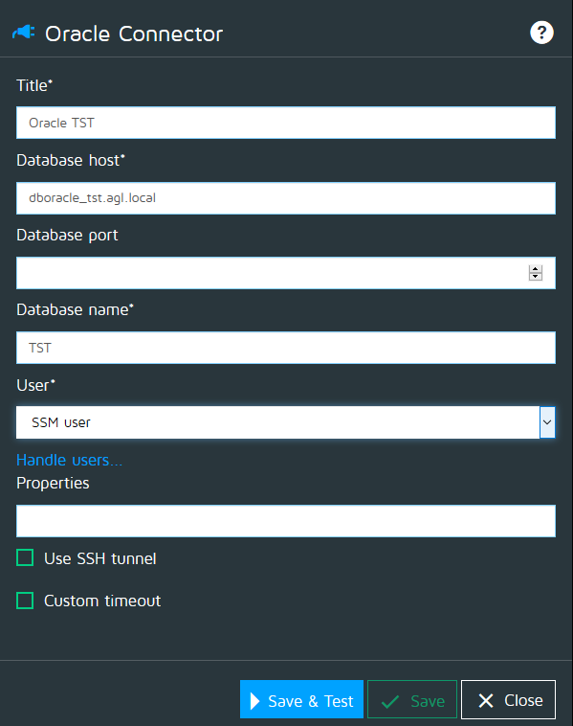

SSH
- In case you must connect to a database through an SSH tunnel, you can enable the SSH option and fill in the parameter:
  - Host: The host where the entrance of the tunnel is created.
  - Port: The local port of the SSH tunnel
  - User: The user to authenticate on the SSH end point.

Custom timeout
- See Custom timeouts
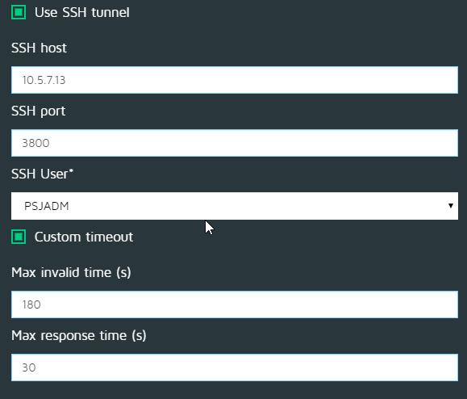

Authorizations
The Oracle monitors will need to peform SELECT queries on the below tables:
- ALL_OBJECTS
- ALL_ERRORS
- DBA_DATA_FILES
- DBA_FREE_SPACE
- DBA_TABLESPACE_USAGE_METRICS
- DBA_TABLESPACES
- DBA_TEMP_FILES
- V$FILESTAT
- V$LIBRARYCACHE
- V$LOG_HISTORY
- V$RESOURCE_LIMIT
- V$RMAN_BACKUP
- V$RMAN_BACKUP_JOB_DETAILS
- V$SYSSTAT
- V$TEMP_SPACE_HEADER

