SAP Powerpack for ScienceLogic SL1
This powerpack enables seamless integration of Redpeaks/Redpeaks
monitoring solution for SAP with SL1 using the REST toolkit.

Overview
- This powerpack facilitates the discovery and monitoring of SAP environments within SL1.
- It utilizes SL1's REST toolkit framework.
- It establishes a connection to Redpeaks/Redpeaks API, providing access to monitoring data.
- Automatic creation and grouping of SAP devices occur seamlessly.
- System metadata, metrics, and alerts are automatically associated with their respective devices for streamlined organization.
- A set of dynamic applications will provide visibility on generated alerts and metrics and can be used to build custom dashboards and automation

Scope
The powerpack specifically focuses on system monitoring across these categories:
- SAP S/4HANA and NetWeaver (starting from version 4.6)
- SAP HANA Database
- SAP BusinessObjects
You will find in the Monitored environments section below an exhaustive list of the monitored components.

Releases
- V1.3.2 (2024-02-15)
  - Important: Use the “Rest snippet framework 101” credentials when aligning with the root level discovery application
  - Documentation update.
- V1.3 (2024-02-13)
  - Uses a copy of the REST toolkit V101 as execution environment.
- V1.2 (2024-01-26)
  - Uses the updated REST toolkit environment.
  - Important: Make sure to use the “Universal” credentials when aligning with the root level discovery application.
- V1.1 (2023/12)
  - Remove the use of cache to fix data collection issue
  - Use JMSEPath instead of JSONPath to improve performance
- V1.0 (2023/11) - First version of this powerpack
  - Support of S/4HANA, NetWeaver, HANA, BusinessObjects
  - Reports all alerts
  - Collects alerts and metrics for ABAP, J2EE, HANA stack sysems.
  - Collects alerts for BusinessObjects systems.

Architecture
- A Redpeaks collector remotely monitors accessible systems.
- An SL1 collector usually connects to one Redpeaks collector within the same network security zone.
- Due to network and resiliency concerns, a 1-to-1 relationship is typical.
- However, it can collect data from multiple Redpeaks instances when needed.
- By example, for monitoring 2 separate SAP landscapes, it is possible to deploy 1 Redpeaks instance for each landscape, both linked to a single SL1 collector.
This is the most typical architecture:
- Monitored SAP systems
- Redpeaks/Redpeaks collector: Remotely connecting to the systems via standard API
- SL1 collector: Performing REST API calls to collect monitoring data
- SL1 instance
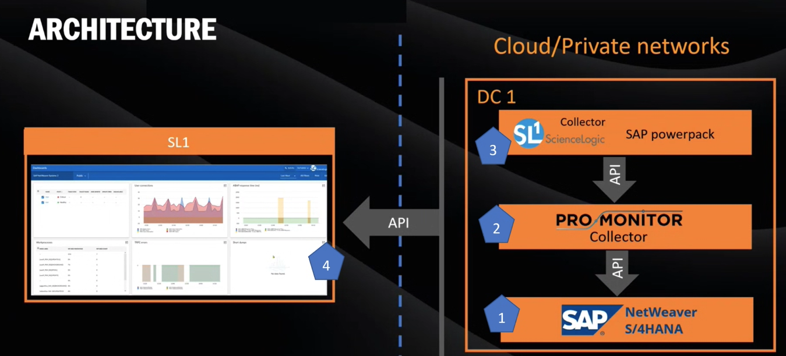

Content

Devices
Defines the types of devices that the powerpack will create and manage.
Type | Name | Description | Version
Device category | SAP.Infrastructure | Root element, containing groups of systems | V1.0
Device category | SAP.Group | Group of SAP systems | V1.0
Device category | SAP.System | SAP system device | V1.0
Device category | SAP.Instance | A component of a SAP system | V1.0
Device class | SAP.Infrastructure | Root device for SAP groups | V1.0
Device class | SAP.Group | Virtual device representing a group | V1.0
Device class | SAP.NetWeaver ABAP | Device for ABAP stack systems | V1.0
Device class | SAP.ABAP instance | Device for ABAP application server | V1.0
Device class | SAP.Java instance | Device for J2EE application server | V1.0
Device class | SAP.HANA system | Device for HANA database | V1.0
Device class | SAP.HANA tenant | Device for HANA tenant | V1.0
Device class | SAP.BusinessObject | Device for BusinessObjects systems | V1.0

Dynamic applications
Those applications will collect metrics and health information for the discovered devices.
Name | Description | Version
ABAP metrics | Collect metrics from ABAP systems | V1.0
ABAP instance metrics | Collect metrics from ABAP instances | V1.0
HANA metrics | Collect metrics from HANA tenants | V1.0
HANA services | Collect HANA services status | V1.0
SAP alerts | Collect alerts from any device | V1.0

Event policies
Those policies define how Redpeaks/Redpeaks events are being converted in to SL1 alerts.
Name | Description
CRITICAL | Maps event to SL1 CRITICAL alert
MAJOR | Maps event to SL1 MAJOR alert
MINOR | Maps event to SL1 MINOR alert
WARNING | Maps event to SL1 NOTICE alert
INFO | Maps event to SL1 NOTICE alert
CLEAR | Maps event to SL1 HEALTHY (suppresses)

Prerequisites
- This powerpack works with SL1 V11.3.0 or later
- It requires the REST toolkit powerpack V101
- It needs Redpeaks/Redpeaks collector version 6.8.5 or above.
- Ensure the Redpeaks collector is both installed and configured.
- Open network routes between the SL1 collector and Redpeaks collector on HTTP/HTTPS ports to allow HTTP REST requests from the SL1 collector to the Redpeaks collector.

Installation
Those are the main steps to complete for configuring the SAP integration in SL1:
- Get SAP monitoring with REST toolkit powerpack from SL1 download center or from redpeaks (support@redpeaks.io)
- Upload and install the SAP powerpack
- Register Redpeaks REST API credentials
- Create a root virtual device for SAP systems discovery
- Assign the discovery dynamic applications to the root device
After having completed those few steps, the SAP infrastructure will be discovered and you will be able to see events and metrics within your SL1 instance.

Upload and install powerpack
- Navigate to the Powerpack section of SL1 settings
- Select Action->Import powerpack and upload the powerpack file
- Once upload is complete, the powerpack installer screen will popup: Press Install
- You should see the new powerpack in the table

Register Credentials
- Navigate to Manage-> credentials
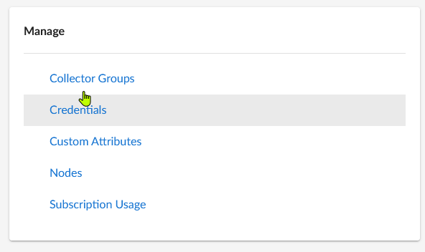
- Create a REST snippet framework 101 credential
- Set the Redpeaks collector URL and authentication parameters
- Use /api/v1/sl1 as API endpoint
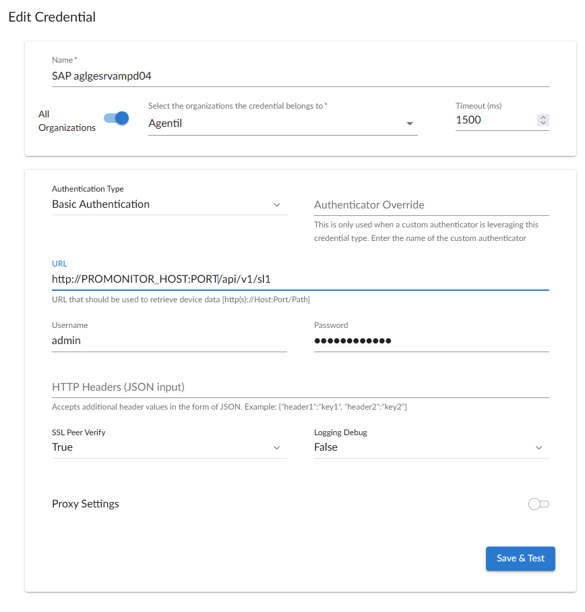
Note:
- If you didn't install you own trusted certificate on Redpeaks instance, you MUST set SSL peer verify to False

Create SAP root device
- Navigate to Device manager
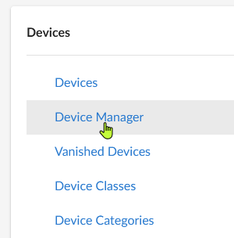
- Create a virtual device
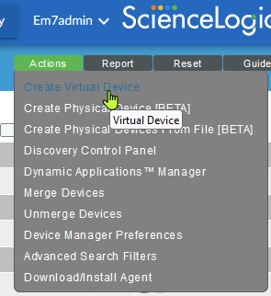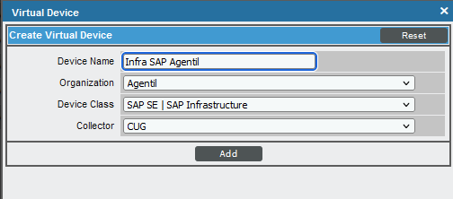

Align discovery applications
- Edit the created device and go to collectors tab
- Assign dynamic applications:
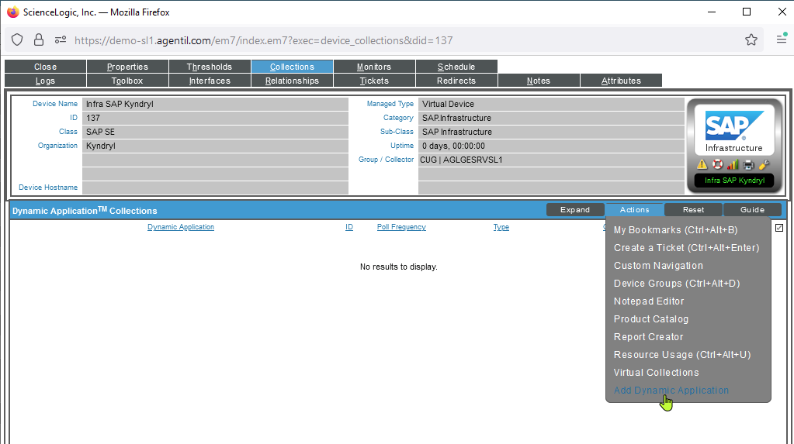
- You need to assign two applications:
  - SAP_RP: SAP alerts
  - SAP_RP: SAP groups discovery
- Select the applications within the list.
- Once clicked on the application name, this will list the available credentials
- Select the credentials that you created and save
- 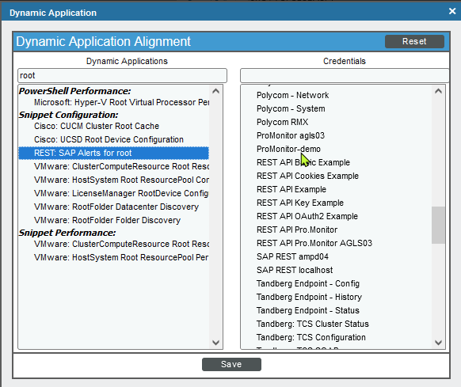
- Once done, you should see two applications aligned with the device.
- From now on, your SAP architecture will be automatically discovered
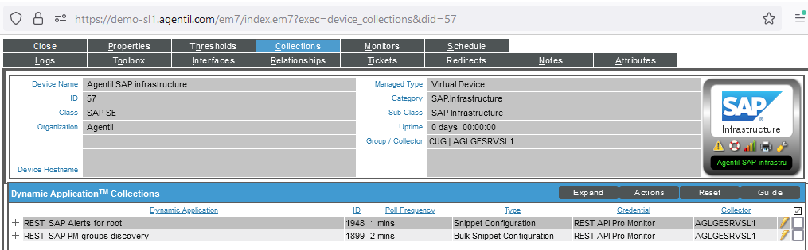

Monitored environments
- This is a description of the discovered devices by environement and associated monitored components

S/4HANA - NetWeaver
Devices | Description
SAP system | The SAP logical system composed by application servers
SAP ABAP instance | An ABAP instance
SAP J2EE instance | A J2EE instance

Components
ABAP instance memory
ABAP instance response time
ABAP locks
ABAP shortdumps
Batch inputs
Database backups
Database size
DB Exclusive locks
Dispatcher queues
ICM status and usage
IDOC exchange monitoring
Instances availability
PI/XI messages ABAP
Process Chains monitoring
Queued RFC
RFC Destinations availability
SAP buffers
SAP change settings
SAPconnect (SCOT/SOST)
SAP Jobs monitoring
SAP transaction times
SAP transports
SAP users
Spools

Components for J2EE
Java components status
Java instances status
Java processes status
SAP Control metrics tree

HANA DB
Devices | Description
HANA system | The SAP logical system composed by one or several tenants
HANA tenant | A tenant database

Components for HANA
Database CPU utilization
Database disk usage
Database memory utilization
HANA backups
HANA connections
HANA nodes status
HANA replication LOG retention statistics
HANA replication shipping statistics
HANA replication status
HANA tables
HANA threads
HANA transactions
Merge statistics
Services status

Monitors for BO connectors
Devices | Description
BusinessObjects system | A standalone BusinessObjects system

Components
Concurrent users
Schedules
Servers status
Server metrics

Support
- For support or feature requests please use our Jira system : https://agentil.atlassian.net/servicedesk/customer/portal/9
- If you don't have an account yet, contact AGENTIL Software at support@redpeaks.io

