Installation

Import and install
- Get the powerpack file
- From SL1 Settings menu, click on PowerPacks section
- From top right Actions button, select import, then pickup the powerpack file and proceed with the import
- Select the imported powerpack and click Install

Pro.Monitor plugin setup

Create API user
- From Pro.Monitor settings, open Users and Authorizations menu
- Go to Users tab and press the Add button to create a new user.
- Enable the Monitoring API user checkbox
- 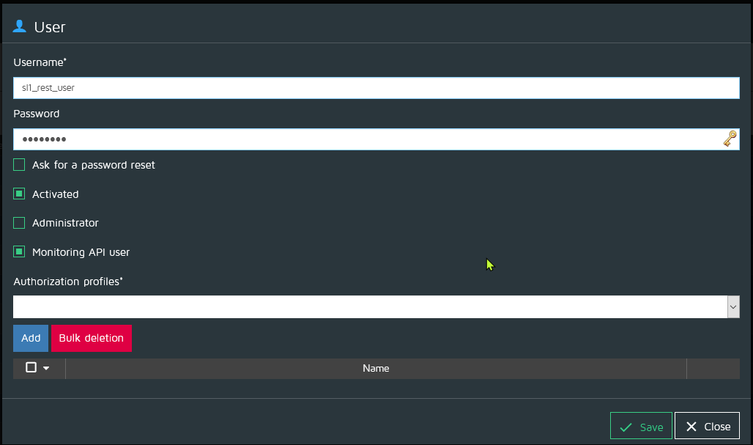

Create Generic events server plugin
- From Pro.Monitor settings, open Plugins menu
- Select Generic events server and press Add
- Fill the formular and activate Enable cache
- 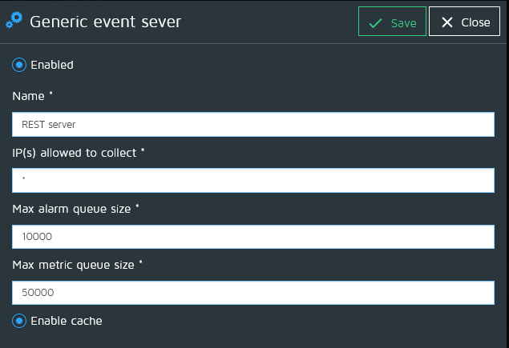

Connect SL1 to Pro.Monitor
- Setup Pro.Monitor plugin first (See above section)

Setup SOAP/XML endpoint
- This actually defines the REST API URL and authentication
- From SL1 Settings menu, click on Credentials section
- From top right Actions button, select Create SOAP/XML host credentials
- Fill the formular as below example
  - Credential profile name
  - Pro.Monitor URL
  - Method POST
  - Pro.Monitor REST API credentials
- 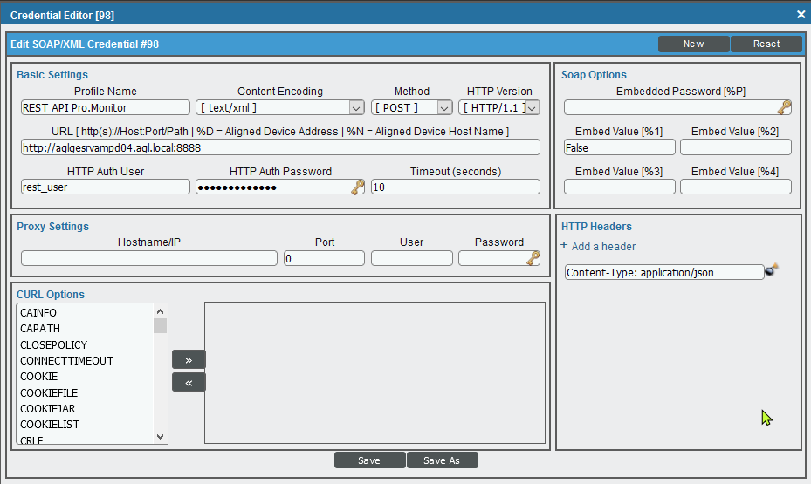

Setup of the virtual device
- This device will be the root on which all discovered systems from the Pro.Monitor endpoint will be bound
- From SL1 Registry menu, click on Device Manager section
- From top right Actions button, select Create Virtual Device
  - Name your device to recognize the Pro.Monitor SAP integration
  - Set Device Class to SAP SE|SAP Infrastructure
  - Associate the proper organization
- Once created, find the virtual device within the Device Manager and open the wrench menu
- Go to Collections tab and from the Actions button select Add Dynamic Application
  - Add REST: SAP Alerts for root
  - Add REST: SAP PM groups discovery
  - Associate your Pro.Monitor credentials while adding each application
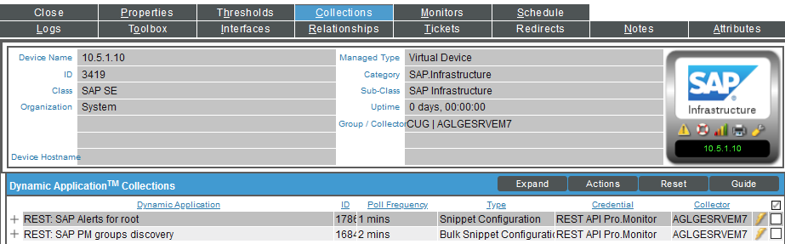
If Pro.Monitor Generic Server plugin is started, the application will start discovering SAP devices.
- Note: You must create one virtual device per Pro.Monitor endpoint you want to collect

