SAP Solution manager connector
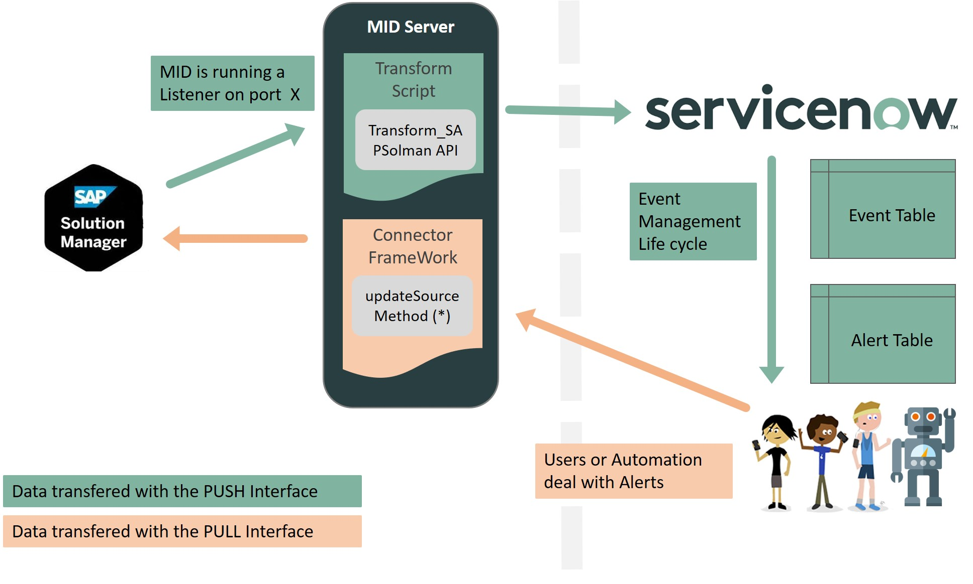
This integration can get alerts from SAP Solution Manager, and perform some actions back in SAP.
- Add comments
- Confirm alerts
- Set the “externally Managed” status

Push interface
Because SAP is only able to push data to an external source, the integration is using the Pull interface to store alerts from SAP to Service Now
SAP Alerts are creating Events and the system go through the Event Management Process, matching event Rules and CI recognition rules to create Alerts, as explained here : Administers Event
The complete ServiceNow Event Management process documentation is available here : Tokyo IT Operations Management

Pull interface
Alert are created in Service Now. By default, a business rule is listening for any change on the alert. If a change is detected, Service Now is updating the SAP Solution Manager Alerts (see Service Now official Documentation related to Push interface for details: here)
This interface is not Mandatory, and the call back to Solution Manager is optional

